CAS PY 106

Pre-session Note 3

Electric Field

1. Three charges in a line
2. 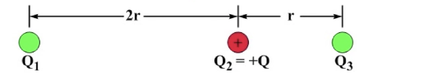
3. Ball 1 has an unknown charge and sign
4. Ball 2 is positive, with a charge of +Q
5. Ball 3 has an unknown non-zero charge and sign
6. Ball 3 is in equilibrium – it feels no net force
7. Sign of the charge on ball 1 is either positive, negative, or we cannot tell
8. Ball 3 is in equilibrium because it experiences equal-and-opposite forces from the other two balls, so ball 1 must have a negative charge. Flipping the sign of the charge on ball 3 reverse both these forces, so they still cancel
9. What is the magnitude of the charge on ball 1? Can we even tell if we don’t know what Q3 is?
10. We can. For the two forces to be equal and opposite, with ball 1 three times as far from ball 3 as ball 2 is, and the distance being separated in the force equation, the charge on ball 1 must have a magnitude of 9Q
11. F3 = F13 + F23 = 0

-kQ1Q3/(3r)^2 + kQ2Q3/r^2 = 0, where Q2= 1Q

Q1/9 = Q

Q1 = 9Q

1. The neat thing is that we don’t need to know anything about ball 3 except the fact that it is at equilibrium. We can put whatever charge we like at the location of ball 3 and it will feel no net force because of balls 1 and 2
2. Two charges in a line
3. 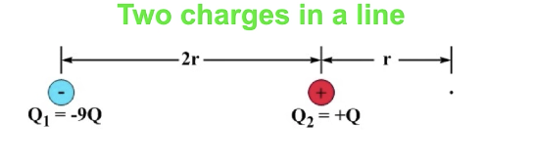
4. Ball 2’s effect on ball 3 is given by F23 = kQQ3/r^2
5. Ball 2’s effect on the point where ball 3 was given by the electric field ball 2 produces E2 = kQ/r^2
6. Ball 1’s field E1 = -9kQ/(3r)^2 = -kQ/r^2
7. The two fields cancel
8. Electric field
9. A field is something that has a magnitude and a direction at every point in space. An example is a gravitational field, symbolized by g. The electric field, E, plays a similar role for charged objects that g does for objects that have mass
10. G has a dual role, because it is also the acceleration due to gravity. If only gravity acts on an object, Fg = mg = ma -🡪 a =g
11. For a charged object acted on by an electric field only, the acceleration is given by: Fe = qE = ma 🡪 a = qE/m
12. Electric field lines
13. Field line diagrams show the direction of the field, and give a qualitative view of the magnitude of the field at various points. The field is strongest where the lines are closer together
14. 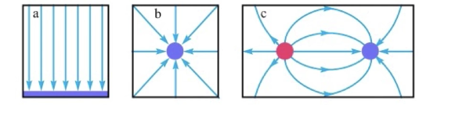
15. A—a uniform electric field directed down
16. B—the field near a negative point charge
17. C—the field lines start on positive charges and end on negative charges. This is an electric dipole – two charges of opposite sign and equal magnitude separated by some distance. The electric field points away from a positive charge and toward a negative charge
18. Electric field vectors
19. Field vectors give an alternative picture and reinforces the idea that there is an electric field everywhere. The field is strongest where the vectors are darker
20. All the vectors are the same length.
21. The more lines there are in an area, the larger the field
22. Getting quantitative about field
23. When we want to know about the electric field at a point, field-line diagram is not useful
24. Use superposition – the net electric field at a particular point is the vector sum of the individual electric fields at that point. The individual fields sometimes come from individual charges. We assume the charges are small, so we call them point charges.
25. Electric field from a point charge E= kq/r^2 – units being N/C or V/m equivalently
26. A test Charge
27. Test charge is a positive charge of such a small magnitude that it has a negligible impact on the field it is sampling.
28. Based on the relationship F=qE, the force on a positive test charge is in direction of the electric field at the point where the test charge is, and the size of the force is proportional to the magnitude of the field at that point
29. 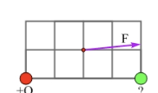
30. Uniform field
31. 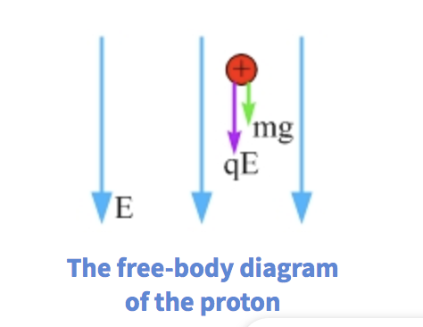
32. Here, there are two forces that are acting on the proton that pulls it downwards

F = ma

qE +mg = ma

a = (qE+mg)/m

a = qE/m + g where g is 9.8m/s^2

1. Since the mass of the proton is very small, the value of qE/m is very high at most times, and therefore, the g value of 9.8m/s^2 is negligible.
2. When we apply the equation xf = xi + vi\*t + ½\*a\*t^2, with the value of xi (initial location) and vi (initial velocity) of 0, we get the equation xf (final x) = ½\*(qE/m+g) \* t^2 where t is time in seconds.